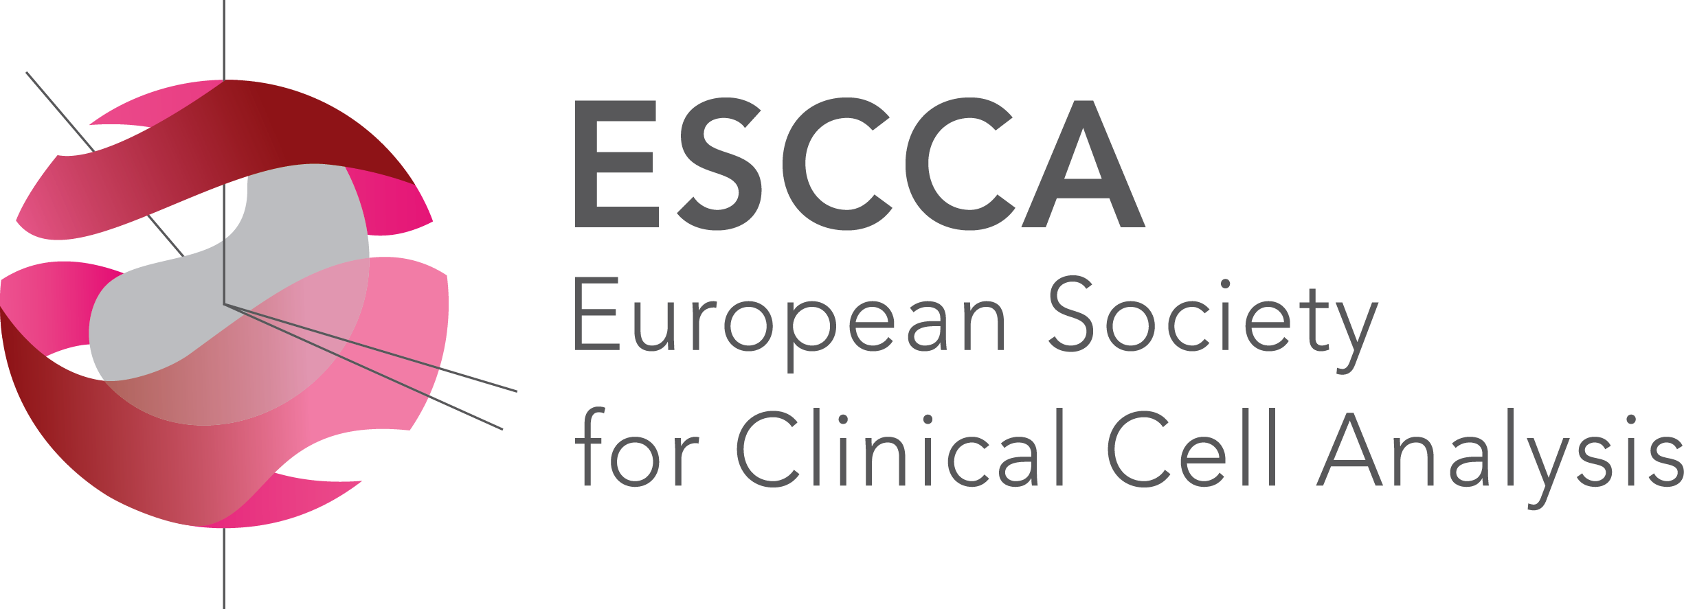 | 6TH International Summer School on Cytometry  8-12 July 2019  Valencia, Spain
REGISTRATION FEES
 | REDUCED * | STANDARD ^{ⱡ}
 | FULL COURSE^{ѻ}
EARLY REGISTRATION(Before 30 June, 2019) | 400 € | 500 €
LATE REGISTRATION(Until 8 July, 2019) | 500 € | 600 €
*) For members of ESCCA, ESCCA-affiliated societies, as well as members of the organizing institutions. Includes Course materials, lunches and coffees, Welcome Party and Course Dinner and membership in ESCCA.
ⱡ) Includes Course materials, lunches and coffees, Welcome Party and Course Dinner and membership in ESCCA.
Attendees of previous ESCCA Schools in Valencia will have 20% reduction in course fees.
Students from emerging countries and from countries with no national Cytometry society may apply for an ESCCA Travel Fellowship covering the cost of registration.
To apply, please send a short CV and a motivation letter to: jose.e.oconnor@uv.es
Course Information and Registration Forms:
https://escca.eu/education/international-course
http://www.cipf.es/web/portada/summer-school
Registration: jose.e.oconnor@uv.es
Additional Information and requests for official Invitation Letters (for Visa purposes): jose.e.oconnor@uv.es

REGISTRATION FORM
Name and Surname:
Address:

e-mail:
Phone:

COURSE CHOICE
(Tick one course)
Course 1 | FLOW CYTOMETRY IN HEMATOLOGY: A TECHNICAL APPROACH
Course 2 | CYTOMETRY OF STEM CELLS: A PRACTICAL APPROACH

EARLY REGISTRATION FEES
REDUCED REGISTRATION |  | STANDARD REGISTRATION
Single Course | 400 € | Single Course | 500 €

LATE REGISTRATION FEES
REDUCED REGISTRATION |  | STANDARD REGISTRATION
Single Course | 500 € | Single Course | 600 €

TOTAL REGISTRATION (€)

Please transfer the funds to:
Bank: BANKIA
IBAN: ES14 2038 9938 4160 0020 4038
SWIFT CODE: CAHMESMMXXX
Account Holder: FCV CENTRO INVESTIGACIÓN PRÍNCIPE FELIPE
VERY IMPORTANT: Please indicate your name and “ESCCA Summer School 2019” as the Concept of the Bank Transfer
For confirmation, please send a copy of this Registration Form to: jose.e.oconnor@uv.es

