***“Vergina and Timios Prodromos monastery”* excursion**



**Date: Saturday 23 September 2017**

**Time: 13.30 – 18.30 hrs.**

On **Saturday September 23d**, we will start our excursion from hotel PORTO PALACE at 13:30 by visiting Vergina (one hour and fifteen minutes’ drive from Thessaloniki), a World Heritage site. You will visit all the treasures of the royal tomb, identified as that of Philip II, who conquered all the Greek cities, paving the way for his son, Alexander and the expansion of the Hellenistic world. Free time for souvenirs.

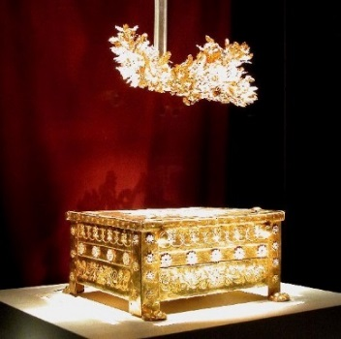 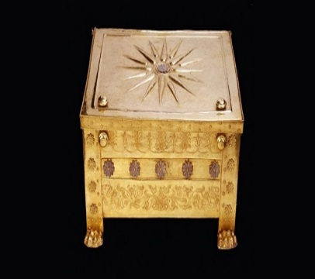 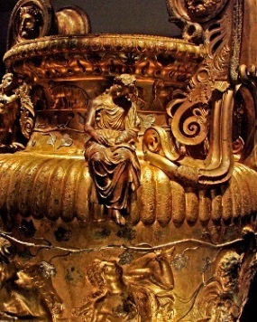 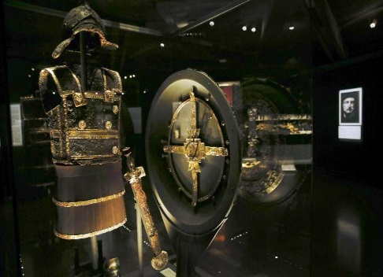

We continue by visiting a unique monastery near the city of Veria, Timios Prodromos monastery, where many saints from the Greek Orthodox Church have lived and followed monasticism. Free time and return to our hotel around 18:30.

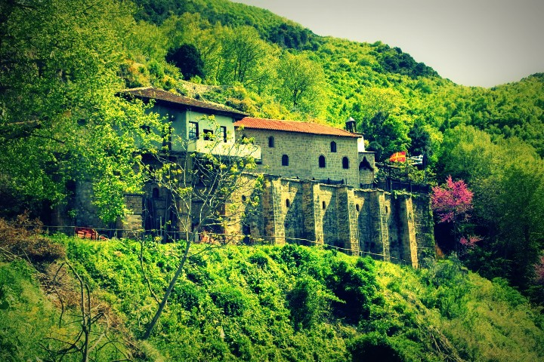 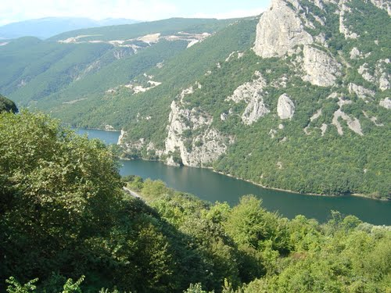

End of excursion.

PRICE PER PERSON IS € 50,00.

Price includes entrance fee at Vergina, bus for the excursion, official English speaking tour guide.

Price does not include tips.

To reserve, see the next page.

*Please send your reservation for* ***Vergina and Timios Prodromos monastery***

*Please be so kind as to sign the authorization form and return it by fax*

**to Splendid Travel fax # 0030-2310-283814 or scanned at email: info@splendid.gr**

Date: …………………………………………

**FROM…………………………………**

TO: *SPLENDID TRAVEL CENTER*

I hereby authorize SPLENDID TRAVEL CENTER, GEORGE G. NIKOLAIDIS S.A. 29, and MITROPOLEOS str. THESSALONIKI GREECE to **charge my credit card**

🞏 VISA 🞏 MASTER

**Name:**

**Credit card number:**

***Expire date:***

**Ccv:**

***With the amount of € 50,00 euros***

***COVERING****: The Vergina and Timios Prodromos monastery tour, on Saturday, September 23d, 2017*

*TOTAL CHARGE* ***= € 50 euros***

**Name:**

**Signature:**

**Date:**

**Contact email for communication:**