

***“Welcome to Thessaloniki”* tour**

**Date: Saturday 23 September 2017**

**Time: 09.30-13.30 hrs. and** **14.30-18.30 hrs.**

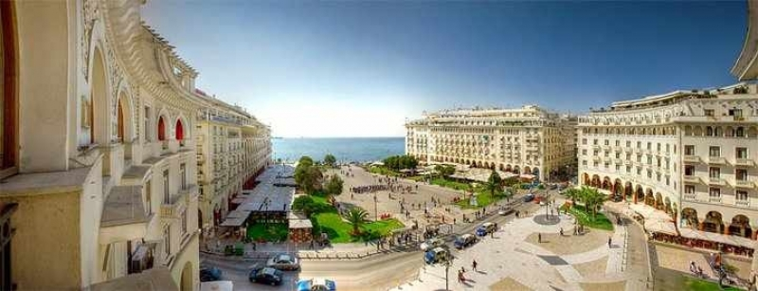

Departure from the Hotel for the best introduction to Thessaloniki. A panorama drive through the city will introduce you to all the main sites and monuments of exceptional historical importance. With our tour guide we will walk through the tiny streets with traditional houses that lead to the Byzantine walls and towers and will stop at the Citadel to enjoy a panoramic view of Thessaloniki.

Later, we will stop at the early Byzantine basilica of Saint Demetrious, built on the ruins of a Roman bath where the patron saint of the city lost his life. Moreover we will have the chance to see the Ancient Roman Agora (Forum) of Thessaloniki.

Additionally, you will see the International Fair of Thessaloniki grounds and the University area. The triumphal Arch of Emperor Galerius. The excellently preserved circular “Rotunda”, and there will be time to take a look at the Galerius Mausoleum.

We will make a photo stop in front of the White Tower - the symbol of Thessaloniki - that stands on the waterfront, and we will walk a bit further to take picture in front of King Alexander’s of Macedonia statue.

End of the tour.

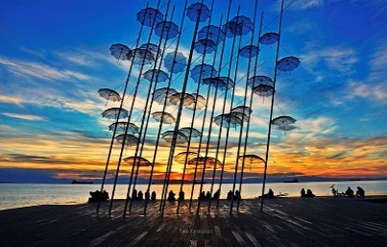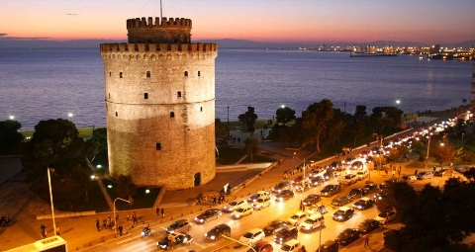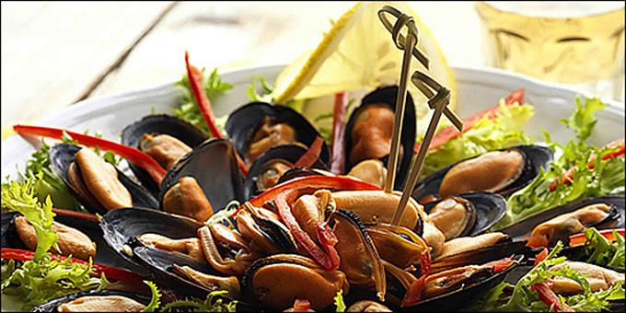

**Price per person € 35,00.**

**Price includes transfer with luxurious bus, entrance fee at Rotunda, official English speaking guide.**

**Minimum participation 15 pax.**

**To reserve, see the next page.**

*Please send your reservation for “****Welcome to Thessaloniki tour****”*

*Please be so kind as to sign the authorization form and return it by fax*

**to Splendid Travel fax # 0030-2310-283814 or scanned at email: info@splendid.gr**

Date: …………………………………………

**FROM…………………………………**

**TO:** *SPLENDID TRAVEL CENTER*

I hereby authorize SPLENDID TRAVEL CENTER, GEORGE G. NIKOLAIDIS S.A. 29, and MITROPOLEOS str. THESSALONIKI GREECE to **charge my credit card**

🞏 VISA 🞏 MASTER

**Name:**

**Credit card number:**

***Expire date:***

**Ccv:**

***With the amount of € 35 euros***

***COVERING****: The WELCOME Thessaloniki tour, on Saturday, September 23d, 2017*

*TOTAL CHARGE* ***= € 35 euros***

**Name:**

**Signature:**

**Date:**

**Contact email for communication:**