

ANCIENT PELLA HALF DAY TOUR (4HRS)

**Date: Saturday 23 September 2017**

**Time: 14.30 – 18.30 hrs.**

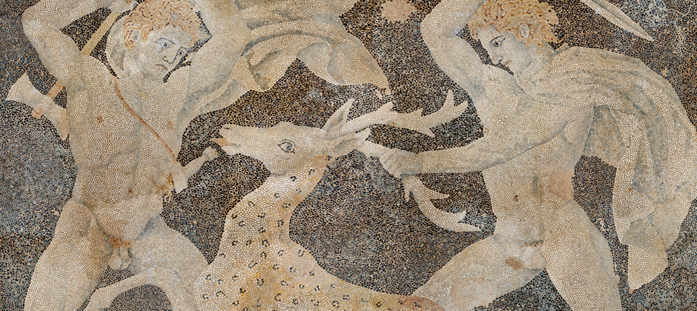

We leave our hotel and within an hour drive we reach Ancient Pella area, the birthplace of Alexander the Great. We will visit the new renovated museum of Pella and we will walk the ancient part of the old city. The museum gives us a clear view of the Macedonian Kingdom and its way of living at the days of King Phillip the 2nd and his son Alexander the Great. The ancient part of the city is interesting because we will see everyday life of Hellenistic period houses. Return to our hotel.

END OF TOUR

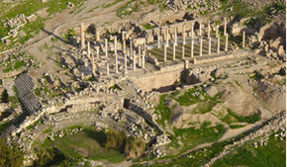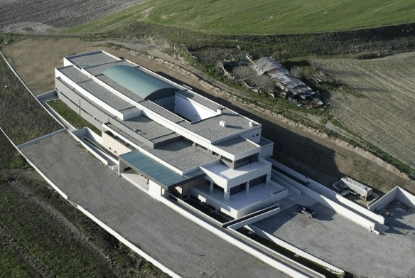

PRICE PER PERSON € 40,00.

Price includes: Transfer with luxurious bus, official English speaking tour guide, entrance fee at the museum.

Price does not include tips.

To reserve, see the next page.

Please send your reservation for “**Ancient Pella half day tour**”

Please be so kind as to sign the authorization form and return it by fax

**to Splendid Travel fax # 0030-2310-283814 or scanned at email: info@splendid.gr**

Date:…………………………………………

**FROM…………………………………**

**TO:** *SPLENDID TRAVEL CENTER*

I hereby authorize SPLENDID TRAVEL CENTER, GEORGE G. NIKOLAIDIS S.A. 29, and MITROPOLEOS str. THESSALONIKI GREECE to **charge my credit card**

🞏 VISA 🞏 MASTER

**Name:**

**Credit card number:**

#### Expire date:

**Ccv:**

***With the amount of € 40 euros***

***COVERING****: The half day trip at Pella, on Saturday, September 23d, 2017*

*TOTAL CHARGE* ***= € 40 euros***

**Name:**

**Signature:**

**Date:**

**Contact email for communication:**